**Early Detection and Prediction of Alzheimer and Parkinson using EEG**

**1. Abstract:**

Machine learning techniques are increasingly being utilized for the early detection and prediction of Alzheimer’s and Parkinson’s diseases using electroencephalogram (EEG) data. This approach involves collecting and preprocessing EEG recordings to remove noise and artifacts, followed by extracting relevant features in the time, frequency, and time-frequency domains. Dimensionality reduction techniques such as PCA are used for feature selection, after which machine learning models like Support Vector Machines, Random Forests, and Neural Networks are trained to classify and predict disease progression. Model performance is evaluated using cross-validation metrics, ensuring robustness and generalizability. The integration of these models into clinical practice promises enhanced diagnostic accuracy and early intervention opportunities, with careful consideration of ethical and privacy concerns.

**2. Objectives:**

1. Develop a machine learning model for the detection of Alzheimer and Parkinson using electroencephalography (EEG) signals.

2. Explore deep learning architectures to improve the accuracy and robustness of disease detection algorithms.

3. Investigate feature extraction methods to capture relevant patterns indicative of disease states.

4. Implement real-time monitoring systems for continuous state of disease detection and prediction.

5. Evaluate the performance of the proposed models on diverse EEG datasets to assess generalizability and reliability.

**3. Methodology:**

1. Data Collection: Acquire EEG data from public datasets, ensuring a diverse representation of disease types and patient demographics.

2. Pre-processing: Clean and per-process EEG signals to remove artifacts and noise, and standardize the data for analysis.

3. Feature Extraction: Extract informative features from EEG signals using time-domain, frequency-domain, and time-frequency analysis techniques.

4. Model Development: Train machine learning models, including traditional classifiers and deep learning architectures, on the extracted features to detect epileptic seizures.

5.Real-time Monitoring: Implement a real-time monitoring system capable of processing EEG data streams for continuous seizure detection and prediction.

6. Performance Evaluation: Evaluate the developed models using standard metrics such as accuracy, sensitivity, specificity, and area under the receiver operating characteristic curve (AUC). Conduct cross-validation and external validation to assess model performance robustness.

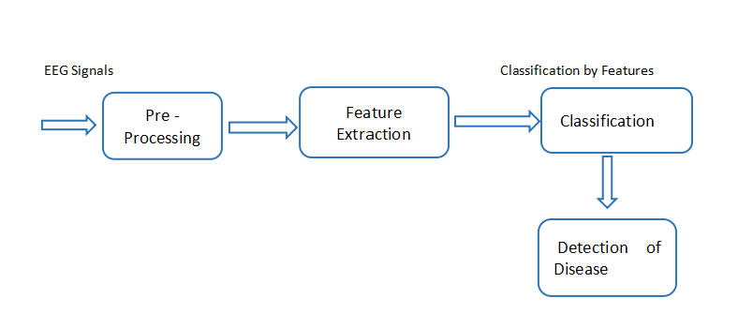

Fig 1: Generalization of detection system

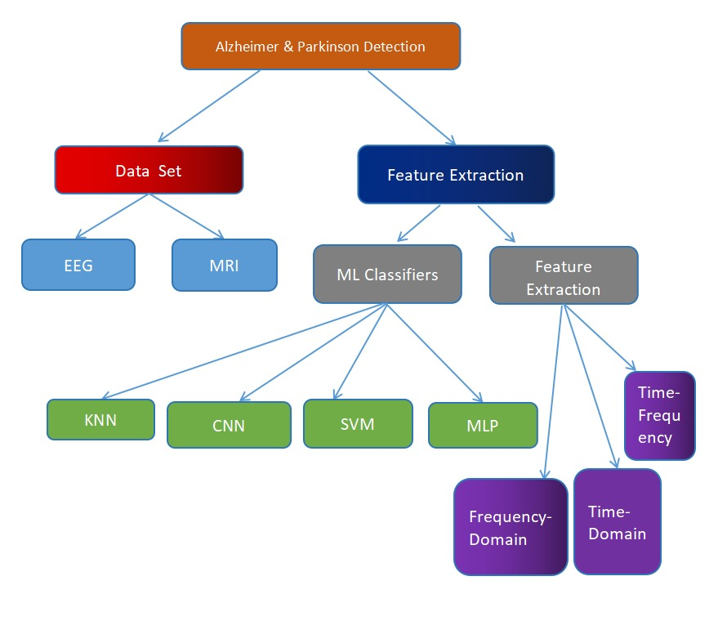

Fig 2: Disease Detection Techniques.

**4. Expected Outcomes:**

1. Development of accurate and efficient machine learning models for the detection and prediction of type of disease.

2. Identification of key features and biomarkers indicative of which state the disease is and contributing to a deeper understanding.

3. Implementation of a real-time monitoring system capable of providing timely alerts and interventions for patients at risk .

4. Contribution to the advancement of AI-based healthcare technologies for epilepsy management and patient care.

**5. Significance and Impact:**

1. Early detection and prediction of Alzheimer and Parkinson can significantly improve patient outcomes by enabling timely interventions and treatments.

2. AI-based approaches have the potential to enhance the accuracy and reliability of existing disease detection methods, leading to better patient care and quality of life.

**6. Conclusion:**

In conclusion, the application of machine learning to EEG data holds significant promise for the early detection and prediction of Alzheimer’s and Parkinson’s diseases. By leveraging sophisticated algorithms and advanced feature extraction techniques, these models can identify subtle patterns in brain activity indicative of early-stage neuro degeneration. The deployment of these models in clinical settings can facilitate timely and accurate diagnosis, enabling earlier interventions that may slow disease progression. Continuous improvement and validation of these models, combined with adherence to ethical standards and data privacy regulations, will be essential to maximize their clinical utility and ensure patient trust. This innovative approach represents a crucial advancement in the fight against neurodegenerative diseases.

**7. References:**

1. M. Neufeld, S. Blumen, I. Aitkin, Y. Parmet and A. Korczyn, "EEG frequency analysis in demented and nondemented parkinsonian patients", *Dementia and Geriatric Cognitive Disorders*, vol. 5, no. 1, pp. 23-28, 1994.
2. G. Rodriguez, F. Copello, P. Vitali, G. Perego and F. Nobili, "EEG spectral profile to stage Alzheimer’s disease", *Clinical Neurophysiology*, vol. 110, no. 10, pp. 1831-1837, 1999.
3. L. Bonanni, A. Thomas, P. Tiraboschi, B. Perfetti, S. Varanese and M. Onofrj, "EEG comparisons in early Alzheimer’s disease dementia with Lewy bodies and Parkinson’s disease with dementia patients with a 2-year follow-up", *Brain*, vol. 131, no. 3, pp. 690-705, 2008.
4. F. C. Morabito, M. Campolo, C. Ieracitano, J. M. Ebadi, L. Bonanno, A. Bramanti, et al., "Deep convolutional neural networks for classification of mild cognitive impaired and Alzheimer’s disease patients from scalp EEG recordings", *Proc. IEEE 2nd Int. Forum Res. Technol. Soc. Ind. Leveraging Better Tomorrow (RTSI)*, pp. 1-6, Sep. 2016.
5. G. Fiscon, E. Weitschek, A. Cialini, G. Felici, P. Bertolazzi, S. De Salvo, et al., "Combining EEG signal processing with supervised methods for Alzheimer’s patients’ classification", *BMC Med. Inform. Decis. Making*, vol. 18, no. 1, pp. 1-10, 2018.
6. R. Yuvaraj, U. Rajendra Acharya and Y. Hagiwara, "A novel Parkinson’s disease diagnosis index using higher-order spectra features in EEG signals", *Neural Computing and Applications*, vol. 30, no. 4, pp. 1225-1235, 2018.
7. J. P. Amezquita-Sanchez, N. Mammone, F. C. Morabito, S. Marino and H. Adeli, "A novel methodology for automated differential diagnosis of mild cognitive impairment and the Alzheimer’s disease using EEG signals", *J. Neurosci. Methods*, vol. 322, pp. 88-95, Jul. 2019.
8. M. F. Anjum, S. Dasgupta, R. Mudumbai, A. Singh, J. F. Cavanagh and N. S. Narayanan, "Linear predictive coding distinguishes spectral EEG features of Parkinson’s disease", *Parkinsonism & related disorders*, vol. 79, pp. 79-85, 2020.
9. R. Sugden and P. Diamandis, "Generalizable electroencephalographic classification of Parkinson’s disease using deep learning", *medRxiv*, 2022.